How to Publish JSP Web Apps

that have Java Classes and/or database access

1. Overview 2
2. Locate Your NetBeans Project Locally 2
3. Connect to cis-linux2 using Secure File Transfer Client (Windows Users) 2
4. Connect to cis-linux2 using CyberDuck (Mac Users) 2
5. Publish Your Web Application (with Classes) 3
6. Test a JSP Page (that uses Java Classes) 4
7. Troubleshooting – Tomcat Cannot Find Classes 4
8. Troubleshooting- Resource Not Available 5
9. Troubleshooting – If All Else Fails 5

Overview
In this document, you will learn how to use Secure File Transfer Client (Windows) or Cyberduck (MAC) to publish a web application that references java classes (and/or a database)

Locate Your NetBeans Project Locally
If you are unsure where your project is:
- right click on the project name (from NetBeans Project pane) and select properties.
- You will probably find your files stored under your Documents\NetBeansProjects\ProjectName folder

You must start with a Web Application that NetBeans has run locally without compiler errors.

Connect to cis-linux2 using Secure File Transfer Client (Windows Users)
Now that we know where everything is stored (the jsp pages, the java class files), we are ready to try to publish the web application, so

- Run Secure File Transfer Client and Select Menu option: File – Connect

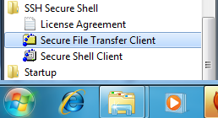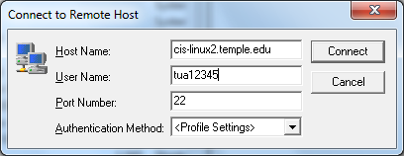

- Enter the name of the temple web server, enter your NetAccess Username, then click on the Connect button.
- In the next window, type in your NetAccess (tumail) password.

Connect to cis-linux2 using CyberDuck (Mac Users)

Publish Your Web Application (with Classes)
To publish classes, this is how your files need to be arranged on the web server (see below). Note that the blue files/folders are organized the same in your project on your local machine as they need to be organized on the server. Note that the xml file is different: sun-web.xml contains settings for your local JSP software (glassfish), whereas web.xml contains settings for the server JSP software (tomcat).

Your Project (Local Machine) |  | Remote Web Server (cis-linux2.temple.edu)
KyverProjecct [your local project folder]  build  web  JSP pages and CSS files  Image folder (with image files inside)  WEB-INF  classes  dbUtils [folder/package]  DbConn.class  FormatUtils.class  view [folder/package]  CustomerVeiw.class  lib  mysql-connector….jar  sun-web.xml |  | SP16_2308_tua12345 [your remote web root folder]  JSP pages and CSS files  Image folder (with image files inside)  WEB-INF  classes  dbUtils [folder/package]  DbConn.class [not .java files]  FormatUtils.class  view [folder/package]  CustomerVeiw.class  lib  mysql-connector…bin.jar  web.xml [download from my web site]

THE FIRST TIME:
- Drag the contents of your localProject\build\web folder up to your remote web root folder (this will publish all the blue files/folders (plus the sun-web.xml which you then have to delete from the server).
- Download copy of web.xml from our class labs page and put that inside the WEB-INF folder on the server
- Save a backup copy of web.xml in your NetBeans Project folder on your PC/MAC because you may need it later.

SUBSEQUENT TIMES:
- Update your new JSP pages (images, CSS files, etc.) to your remote web root folder.
- Update any new packages and class files up to the server.
- On the server, right click and copy web.xml into the clipboard, then delete it, wait a several seconds, then paste it back in (right where it was) – this tells tomcat that you have redeployed your class files and so it will go and get the latest files and start using them. If you do not do this (web.xml copy/delete/paste), tomcat will not see your newly published class files.

Test a JSP Page (that uses Java Classes)
Test by entering your URL into a browser:

- http://cis-linux2.temple.edu:8080/SP15_2308_tua12345/display_using_classes.jsp
- Make sure to click on the browser’s refresh button. Or if you think your browser is caching old pages, clear the browser’s cache by doing Control-F5 (or cleaning out cookies etc from your browser settings).

Troubleshooting – Tomcat Cannot Find Classes
If you get an error message indicating it cannot resolve a package name or a class name, or it says your class name resolves to a package, it means that Tomcat is saying that it cannot find your class (in this example, the class it cannot find is named “ValidationUtils”).

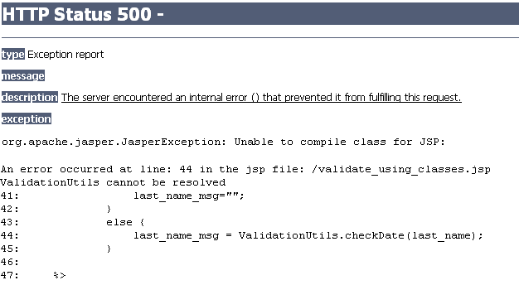

To try to resolve the problem, you can
- Repeat the above process being more careful -- make sure you have copied the “.class” files and they are in the correct folders.
- You can wait a bit longer when you do the copy/delete/wait/paste of web.xml on the server (after uploading the “.class” files.

Troubleshooting- Resource Not Available
If you get a “resource not available” error or an image shows up as a little grey box, check that you did not forget to upload a jsp page, css file, javascript file, or image file that is being referenced.
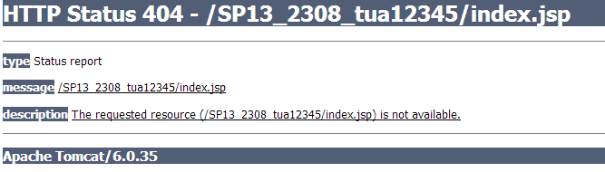
If you are sure the file (or other resource) is there, then check the permissions of the files and folders on the server. To check or change permissions, right click on the file and select Properties.

All FILEs should have Permission Mode 664. Everyone can only read. You and your group can read and write.  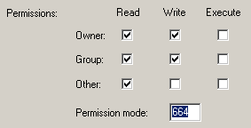 | All FOLDERs should have Permission Mode 771. Everyone can execute but only you and your group can read/write/execute.  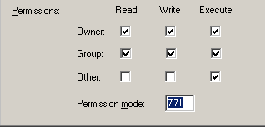

Troubleshooting – If All Else Fails
If all else fails and Tomcat is not recognizing your class files:

- Use the tutorial entitled “Trouble Deploying your Web App”. In this tutorial, you log into the cis-linux2 using secure telnet (from Secure Shell Client – unix command prompt) and you expand a war file (a war file is like a zip file that contains java code). This usually does the trick.
- If you are unable to delete any of your own files, email me – I have to ask the IT admin staff to reset the file permissions.
- If you are still unable to publish your application, email me and I will help you.

